**Azure Based Engine for GridServer 6.2.0**

**Summary:**

This solution provides one or more virtual machines in Azure which are configured to connect to the director, the IP and FQDN for which are provided at the time the marketplace offering is purchased. The solution assumes that the customer is either 1> running one or more on-premise managers and has a VPN connection between their Azure account and their managers already setup, or 2> they are running their grid in Azure and already have a virtual network setup to which they intend to add the engine VM.

This solution is intended for existing Gridserver 6.2.0 customers who should already be familiar with how to setup and configure a grid. The customer must also have an Azure account which allows them to purchase the solution in the Azure Marketplace.

**Requirements:**

If the customer intends to use an on-premise manager, then they will need to setup a VPN solution between Azure and their on-premise systems. The following links provide some instruction on how this is accomplished:

* <https://azure.microsoft.com/en-us/documentation/articles/vpn-gateway-howto-point-to-site-rm-ps/>
* <https://technet.microsoft.com/en-us/library/dn786406.aspx>
* <https://azure.microsoft.com/en-us/documentation/articles/virtual-networks-name-resolution-for-vms-and-role-instances/>
* <https://azure.microsoft.com/en-us/documentation/articles/cloud-services-custom-domain-name/>
* <http://www.serverwatch.com/server-tutorials/azure-virtual-network-primer-overview-and-qa-for-it-pros.html>

If the customer intends to use an Azure-based manager, they will need to have the manager(s) setup on a virtual network and during the purchase of the marketplace offering, they will need to select that network.

The following needs to be supplied regardless of the way the rest of the grid is setup:

1> Director IP

2> Director FQDN

3> A VM Name that is unique (can't be "gridengine", but could be "gridengineyyyymmddhhmmssSSSS") in the example screenshots, we use gseyyyymmddhhmm.

**Tutorial:**

After logging in to the Azure portal, the customer selects the Azure Marketplace:

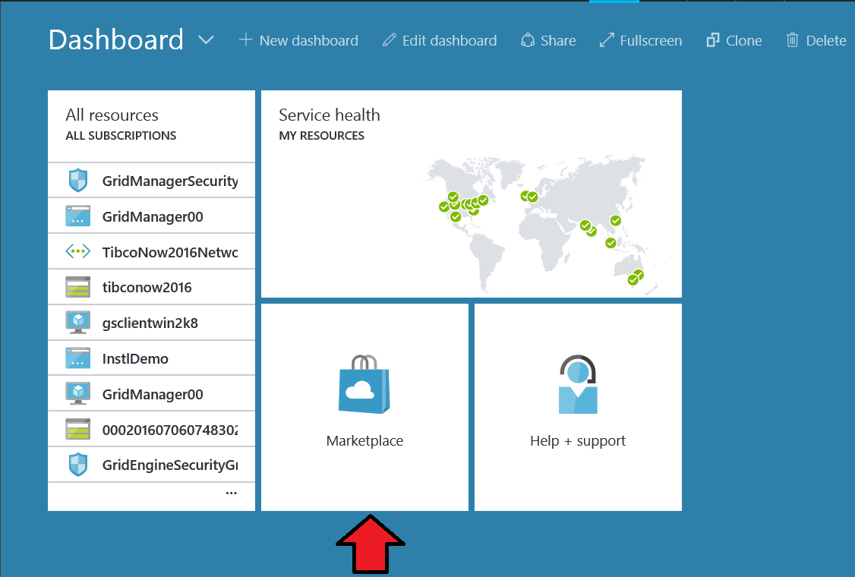

Within the Azure Marketplace, the customer needs to find the Grid Server 6.2.0 Engine offering

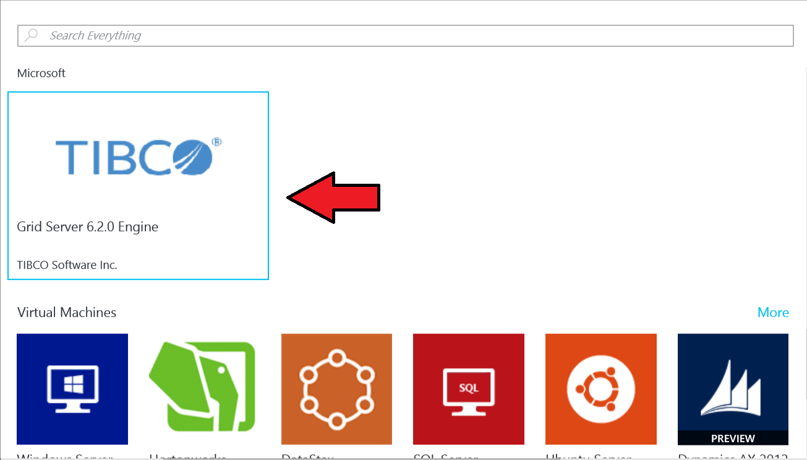

After selecting the Grid Server 6.2.0 Engine, the customer needs to create the deployment to start the process

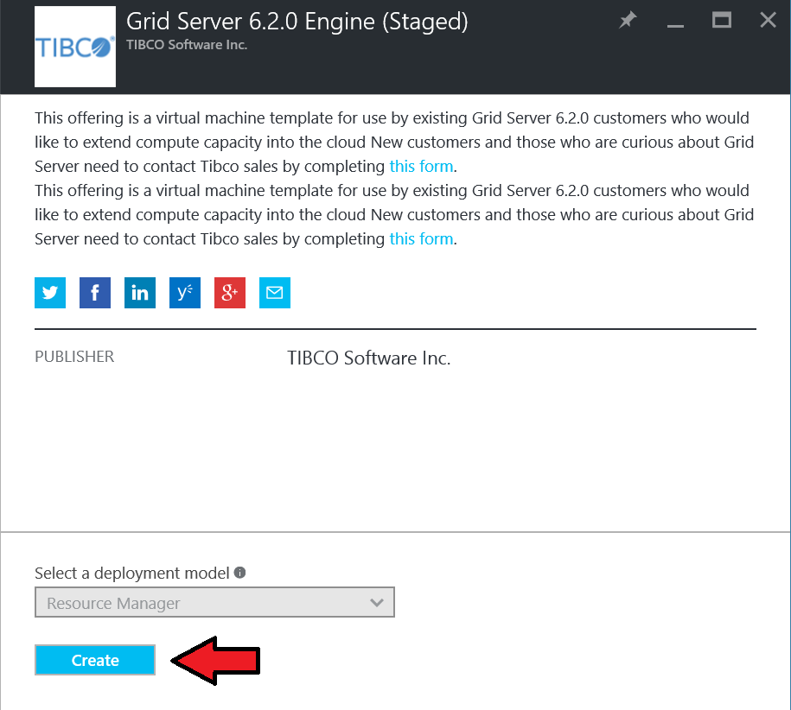

The customer begins the configuration process in the “Basics” section. The following fields need to be filled in:

**Username:** This is the administrative user on the VM. This user ID will be used during the configuration process as the engine application is configured and launched.

**Authentication Type:** This should default to password, but SSH public key can also be selected

**Password or SSH Public Key:** Based on the selection in the Authentication type, the customer will have to supply a password or SSH Public Key for authentication.

**Virtual Machine Name:** This should be a unique value. For simplicity, we are recommending making this value the same as the Resource Group name and the Storage Account Name.

**Director IP Address:** The IP address for the Director.

**Director FQDN:** This is the hostname value that appears in the upper right portion of the manager UI.

**Director Comm Port:** This is the communication port used by engines to connect to the director.

Subscription: This should default to the Azure subscription you’re signed in under.

**Resource Group:** Must be unique and should not be a resource group that already exists. At this time there is only the option to “Create new”, though Microsoft is working toward allowing an option to “Use Existing”. We recommend that you use the same value you entered for the VMName.

Location: Choose a region from the dropdown that is appropriate for your implementation. For instance, if you are connecting to an on premise manager located in London, don’t choose a region like “Brazil South”.

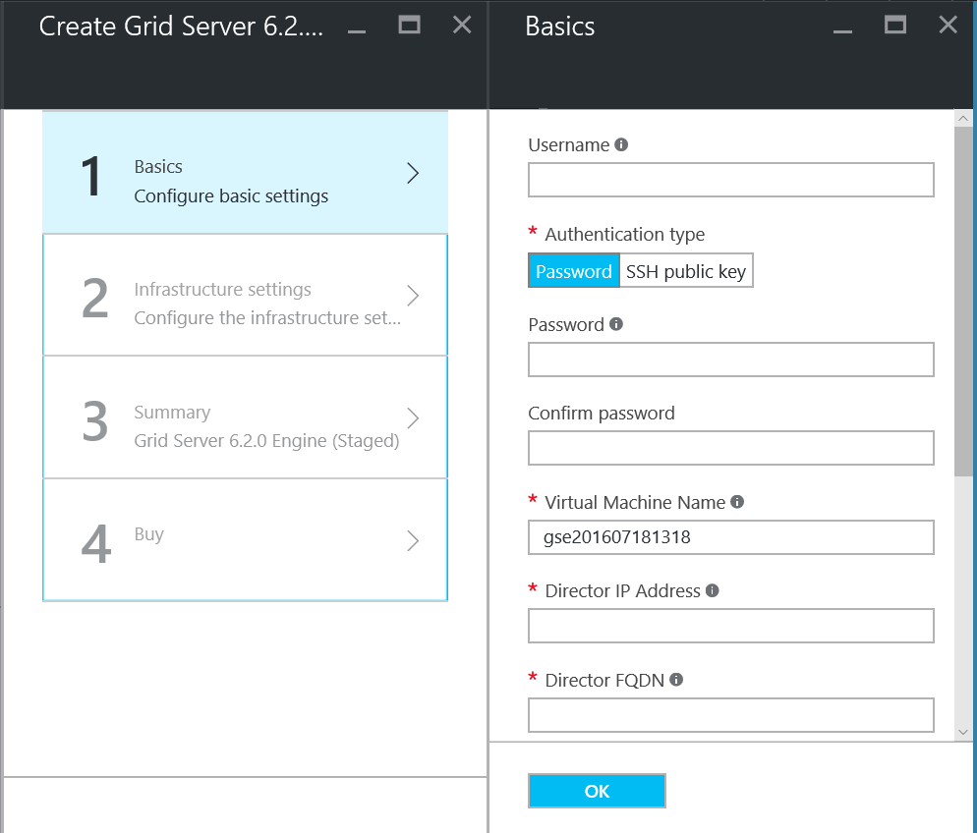

Once the basic section has been completed, the customer will move on to the Infrastructure section. For this tutorial, we break down each individual part of the infrastructure section.

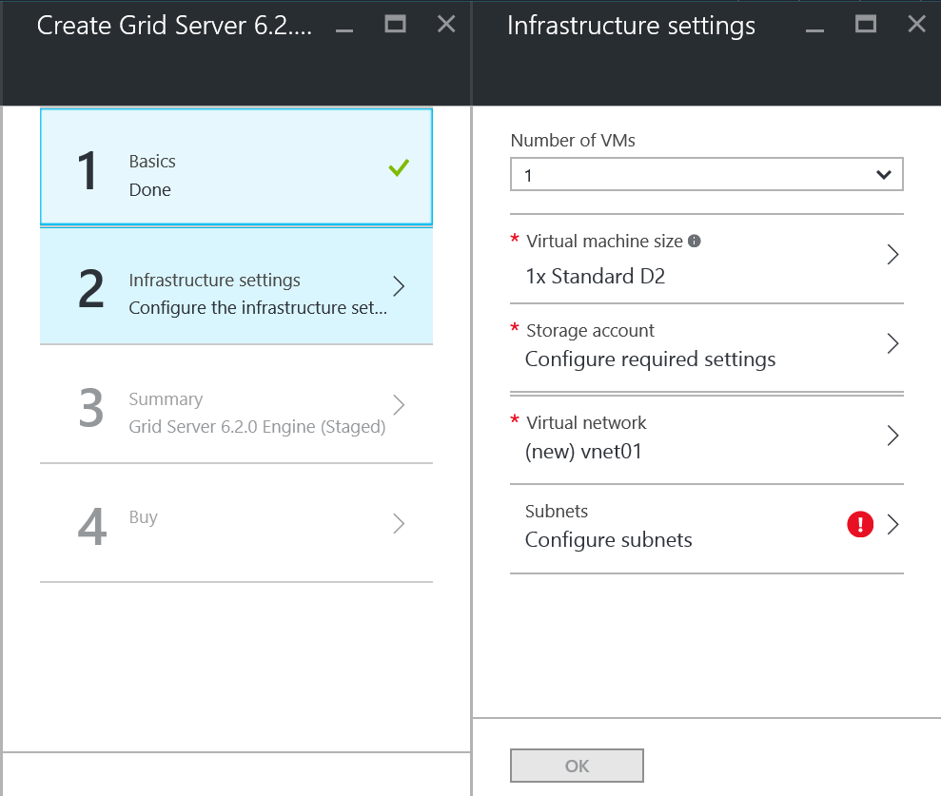

**Infrastructure / Virtual Machine Size:** Choose from the available sizes for the virtual machine. The number of engine instances that are created will be determined by the number of cores on the VM.

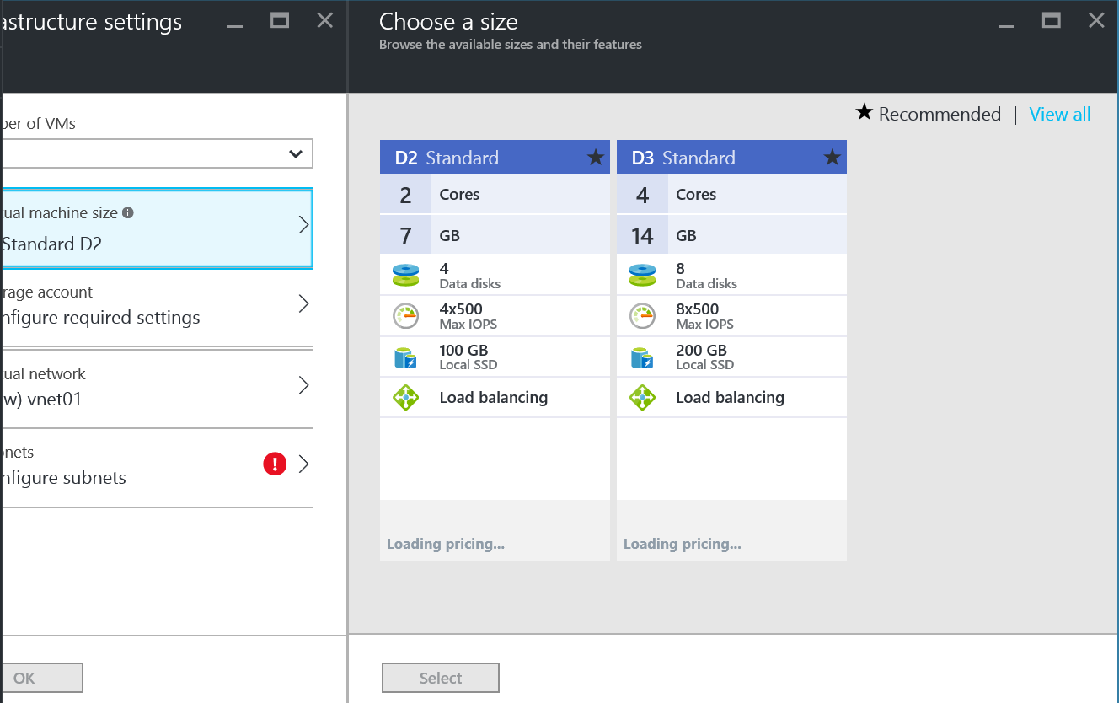

**Infrastructure / Storage Account:** The storage account **must be a GLOBALLY unique value**. This means that your storage account name cannot be in use by anyone else anywhere on Azure. Again, we recommend that the VM Name, the Resource Group name and the storage account name be the same for ease of use. Using an identifier for your company together with something that identifies the VM as a Grid Server Engine (we just use “gse” in our testing) along with the date and time in numeric format seems to work well. So if you’re company is “ABC” you might use “abcgse20160830153524” as a value. For our bursting solution using Azure, we include the millisecond value as well decrease the chance of duplication.

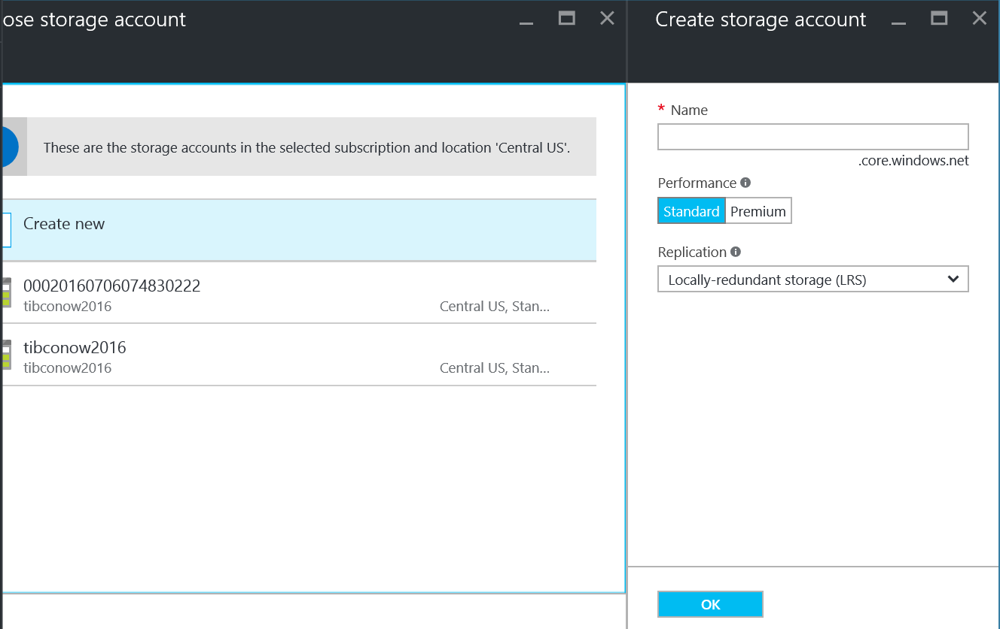

**Infrastructure / Virtual Network:** For the virtual network we **strongly advise you** to have the virtual network setup first and fully tested to ensure there are no connectivity issues. Please refer to the links near the beginning of this document and Azure support for assistance in setting up a virtual network.

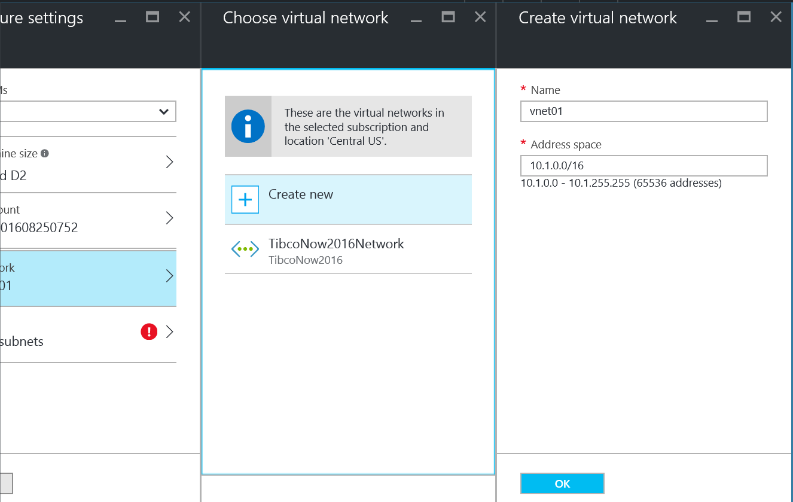

**Infrastructure / Virtual Network:** The customer’s choice here will be guided by how they’ve setup their virtual network. In our example we had one subnet named “default”

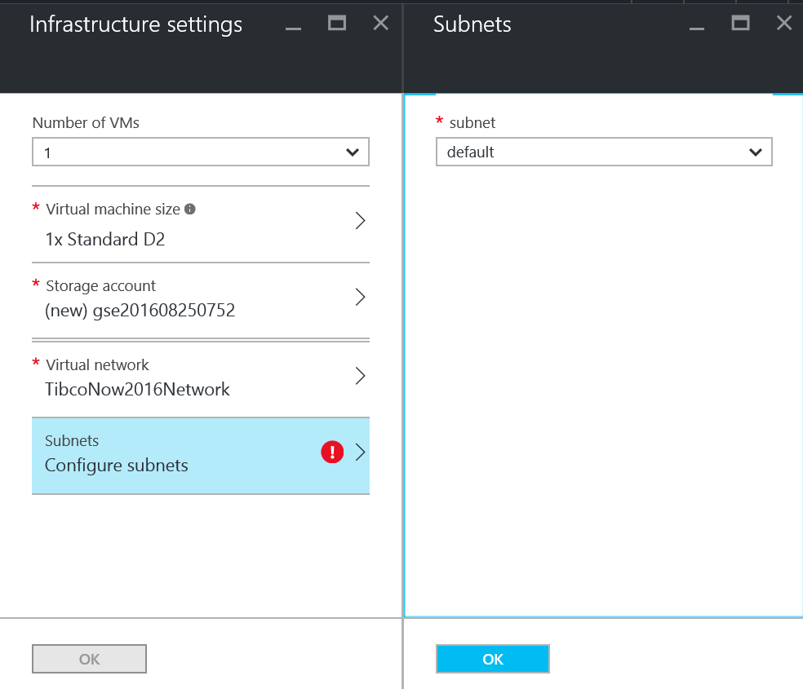

**Summary:** Once the infrastructure settings are complete and “OK” selected, the Azure Portal will take the user to the Summary page where they can review their choices.

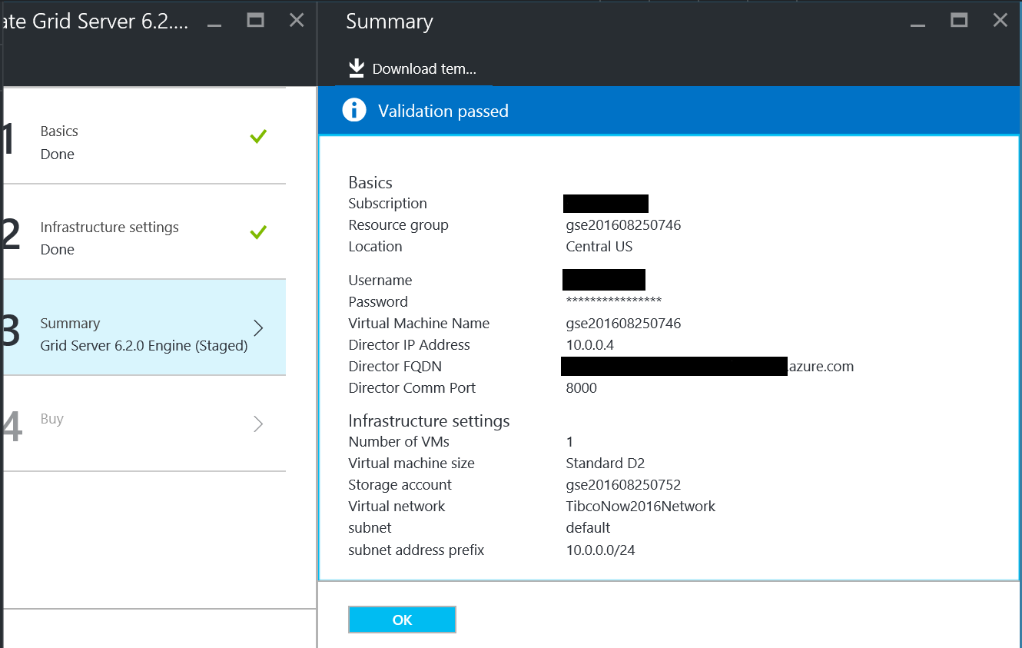

Once the Summary has been approved. The user is presented with the EULA and the option to purchase the Azure Marketplace offering.

